Unilever SharePoint CoE

**Uplift**

**quality SharePoint site functionalities**

Business Requirements Document

**VerSion:** 1.0

**REQUIREMENTS ELICITATION AND DOCUMENTATION TIMELINE:**

Start Date: 28 Mar 2018

Target End Date: 30 mar 2018

Actual End Date:

Contents

1. Introduction 4

1.1. Project Overview 4

1.2. Assumptions: 4

1.3. Acronyms Used: 5

2. Key Stakeholders 5

3. Key Access Roles 5

4. Requirements Details 6

4.1 Types of Complaints 6

4.1.1 SHEQ 6

4.1.2 NCA 6

4.2 Home Page 6

4.3 NCA Complaint form 7

4.3.1 Entry Screen 7

4.3.2 Decision Tree or Loss tree 9

4.3.3 File upload 9

4.3.4 Product description fields 10

4.3.5 Submit Process 10

4.3.6 Display Form 10

4.4 SHEQ Complaint form 10

4.4.1 Entry Screen 11

4.4.2 File upload 12

4.3.3 Decision Tree or Loss tree 12

4.4.4 Approval check 12

4.4.5 Submit Process 13

4.4.6 Display Form 13

4.5 Report 15

4.6 Flow 15

4.6.1 NCA 15

4.6.2 SHEQ 16

4.7 Notification template 16

4.7.1. Complaint Submitted notification to SCA 16

4.7.2. Complaint Assigned notification to Responsible Person 16

4.7.3. Complaint Resolved/Rejected notification to SCA and User 16

4.8 Out of scope requirements 16

5 User Requirements 17

# Introduction

## 1.1. Project Overview

The requirement of this project is to Uplift Quality site for better user experience and to avoid few manual tasks.

**Details as below**

* Have a better User experience in terms of functionality and feature usage
* Auto populating Customer name field based on Customer number value.
* Populating Reference ID based on the Complaint type field (NCA/SHEQ)
* SHEQ Approval check

## 1.2. Assumptions:

* Loss tree reasons will be predefined set of data and have exact mapping for between Level 1, Level 2, Level 3 and Level 4. Business will provide Loss tree reason mapping for Level 1, Level 2, Level 3 and Level 4. Any change in Loss tree reason mapping will required re estimation
* Considered Browser support for IE 11 and above and Chrome. Site to be responsive.
* There will be no Migration in scope and No external integration with SAP considered for this project.
* **Data required for auto populating few fields based on user input will be defined in SharePoint list and retrieved from these custom lists. Business user will upload the required data in these master lists like Customer, Pack details.**
* Scope does not include any external user access to application
* The approval is manual hence SharePoint or this project will not cover any approval flow here.

## 1.3. Acronyms Used:

|  |  |  |
| --- | --- | --- |
| # | Acronym | Description |
| 1 | SP | SharePoint O365 |
| 2 | AD | Active Directory |
| 3 | OOTB | Out of The Box |
| 4 | UX | User Experience |
| 5 | UI | User Interface |
| 6 | SME | Subject Matter Expert |
| 7 | KEC | Keeping Environment Current |
| 8 | SCA | Site Collection Administrator |
| 9 | O365 | Office 365 |

# 2. Key Stakeholders

|  |  |
| --- | --- |
| Role | Name |
| Director – Talent |  |
| Global Learning Director |  |
| General Manager – HR IT |  |
| Manager – Learning Technology |  |
| Collaboration Product Manager |  |
| Functional Specialist |  |

# 3. Key Access Roles

|  |  |  |
| --- | --- | --- |
| User Type | Explanation | Members |
| Site Collection Administrators | Administrator or Owner of site. | Unilever employee or should have Unilever ID |
| User/CSC/Warehouse/UFS | User who enters or view data | Unilever employee or should have Unilever ID |
| SHEQ Approver | User to approve SHEQ complaint | Unilever employee or should have Unilever ID |

# 4. Requirements Details

Current process of raising SHEQ and NCA complaints is through Unilever remedy

Challenges with current tool

* Lots of manual entry and tasks
* Basic user experience
* Not user friendly

To overcome these challenges and make functionality more user friendly and interactive, new approach is requested by Unilever team on SharePoint online/O365.

New features

* Better user experience
* Auto populating Customer name field based on Customer number value.
* Populating Reference ID based on the Complaint type field
* SHEQ Approval check
* Auto populating data by storing master data/reference data in SharePoint list for easy management.

The detailed requirements are given below.

## 4.1 Types of Complaints

### 4.1.1 SHEQ

Unilever Customer/Trade Complaints Form

### 4.1.2 NCA

Unilever Warehouse/Depot Complaints Form

## 4.2 Home Page

User should be able to Sign in and go to home page. This is the landing page for the user where he will be presented with 2 options, SHEQ and NCA.

**SHEQ**

On click of this user will redirect to SHEQ complaint form with auto populated reference number as below.

SHEQxxxxx

Example - **SHEQ12345**

**NCA**

On click of this user will redirect to NCA complaint form with auto populated reference number as below.

NCAxxxxx

Example - **NCA12345**



User should have ability to view all complaints and search complaint.

## 4.3 NCA Complaint form

All NCA complaints are raised by this form. NCA details comes from Warehouses

### 4.3.1 Entry Screen

The form fields are as per below screenshot and details on auto population are as below.

**Person Responsible** – Responsible person to select by user. All selected person should receive automated email once form is submitted.

**Plant Number** – User will input plant number and based on plan number Plant Name and Plant contact information should auto populate.

Plant Name, Plant Contact Name, Plant Contact Designation, Plant Contact No. to auto populate based on Plant Number selection.

**Customer Number** – User to enter customer number. Based on user number Customer Name & contact details to auto populate.

**Pack Code** – User will enter pack code. Once user enter pack code, user should show warehouse selection option. On selection of warehouse product description should be auto populated to description fields. Refer below product description fields.

**Status** – Below status and datetime stamp to add in dropdown.

1. Submitted
2. Assigned
3. WIP
4. Pending
5. Resolved

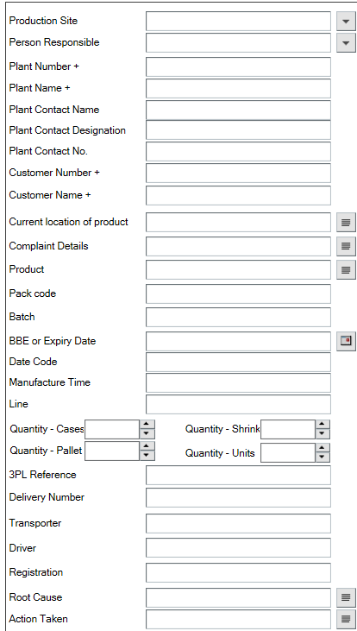

**Pack Code to reflect first, as soon as warehouse types pack code, the product details populate**

**CSC**

**Warehouse**

**1**

**Automated: Warehouse would need to put the customer details as they would’ve received invoice**

s

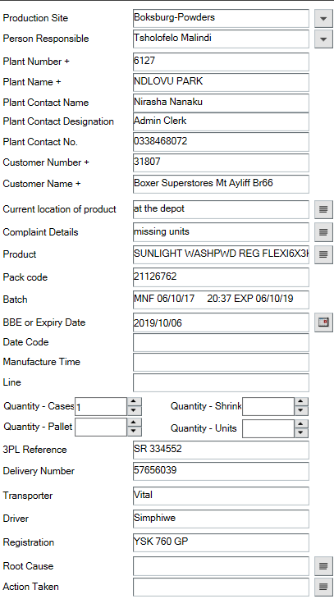

**Quality**

**3PL Reference number – CSC will give warehouse as its populated from SAP CRM**

### 4.3.2 Decision Tree or Loss tree



**CSC**

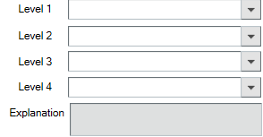

**Auto populated (Decision Tree), see below populated example**

**Quality**

Below Attached spreadsheet feeds into the information that needs to be populate from Level 1 to 4 plus Explanation on the front end. New system should have ability to populate details as per configured master data.



**EXAMPLE OF A COMPLETED NCA**

  
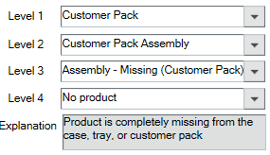

These levels 1-4 are the loss tree reasons from quality which is required to be inputted on new SharePoint as a drop down

### 4.3.3 File upload

User should have ability to upload products **pictures and files except .exe extension file** related to complaint.

### 4.3.4 Product description fields

Should be auto populate based on pack code. Details as below. Products data to come from SharePoint Master data list

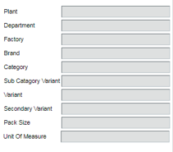

### 4.3.5 Submit Process

Once the user enters required information and save the form. Below flow to perform by SharePoint.

1. User will complete form and **Submit**.
2. SharePoint should update complain status to “Submitted”

**Status = “Submitted”**

1. SharePoint send automated email to SCA for review form and update responsible person if required.
2. SCA will click link to complain form from automated email which will redirect him/her to Complain form.
3. SCA will review form and update responsible person if required and **Assign** complaint by click Assign button.
4. SharePoint should update complain status to “Assigned”

**Status = “Assigned”**

1. Send automated email to all persons selected in “Person Responsible” field with link to complain form.
2. Responsible person will click on the link to complain form from email which will redirect him/her to Complain form. Will view details and work on complains.
3. Responsible person will appropriately set status.
4. If marked as “Resolved” then automated email should trigger and send to complaint owner, SCA.

### 4.3.6 Display Form

OOTB display form will be customised to show the NCA relevant fields data

## 4.4 SHEQ Complaint form

All SHEQ complaints are raised by this form. Details comes from customer.

### 4.4.1 Entry Screen

The form fields are as per below screenshot and details on auto population are as below.

**Site –** Master data list fetched from SharePoint list.

**Person Responsible** – Responsible person to select by user. All selected person should receive automated email once form is submitted.

**Customer Number** – User to enter customer number. Based on user number Customer information to auto populate. If information not present in system, then user should allow to enter same manually.

**Pack Code** – User will enter pack code. Based on pack code, product details should be auto populated.

Product details fields to auto populates are – Product, Plant, Department, Factory

**Status** – Below status and datetime stamp to add in dropdown.

1. Submitted
2. Assigned
3. WIP
4. Pending
5. Resolved
6. Rejected

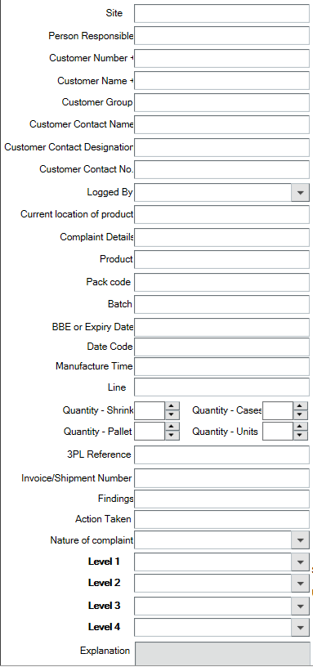

**Pack Code to reflect first, as soon as warehouse types pack code, the product details populate**

**FIELD SALES**

**CSC**

### 4.4.2 File upload

User should have ability to upload products **pictures and files except .exe extension file** related to complaint.

### 4.3.3 Decision Tree or Loss tree

Below Attached spreadsheet feeds into the information that needs to be populate from Level 1 to 4 plus Explanation on the front end. New system should have ability to populate details as per configured master data.



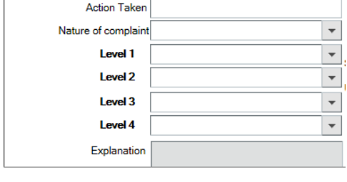

**Quality**

**Auto populated (Decision Tree), see below populated example**

### 4.4.4 Approval check

Fields to add for approval check are as below.

Date of last delivery

Invoice Number

Invoice Value

Approver Ahmed Abdool – Yes / No – **this should be a filter**

Comment – To add comment about approver

If Yes then status = Assigned (Continue) and No then status = Rejected

Above fields are entry fields and user will input those manually.

### 4.4.5 Submit Process

Once the user enters required information and submit the form. Below flow to perform by SharePoint.

1. User will complete form and Submit.
2. SharePoint should update complain status to “Submitted”

**Status = “Submitted”**

1. SharePoint send automated email to SCA for review form and update responsible person if required.
2. SCA will click link to complain form from automated email which will redirect him/her to Complain form.
3. SCA will review form and update responsible person if required and Assign complaint by click Assign button.
4. SharePoint should update complain status to “Assigned”

**Status = “Assigned”**

1. Send an automated email to SHEQ Approval for reviewing complaint.
2. SHEQ approver click link to complaint form from automated email which will redirect him/her to complaint form.
3. SHEQ approver view form and complete “Approval Check” fields and select “Approver Ahmed Abdool” to Yes or No.
4. If “No” selected, then status should change to “Rejected” and complaint will not continue. Appropriate email should send by SharePoint to Complaints Owner/User and SCA.

**Status = “Rejected”**

1. If “Yes” selected, then continue with flow by step number 12.
2. Send automated email to all persons selected in “Person Responsible” field with link to complain form.
3. Responsible person will click on the link to complain form from email which will redirect him/her to Complain form. Will view details and work on complains.
4. Responsible person will appropriately set status.
5. If marked as “Resolved” or “Rejected” then automated email should trigger and send to complaint owner, SCA.

### 4.4.6 Display Form

OOTB display form will be customised to show the SHEQ relevant fields data

Sample form with data

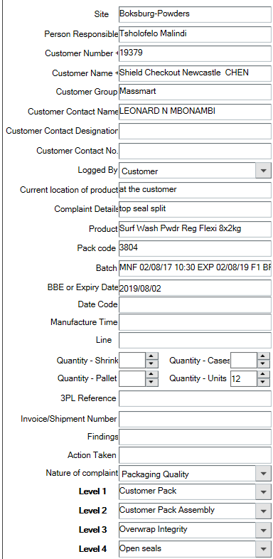

These levels 1-4 are the loss tree reasons from quality which is required to be inputted on new SharePoint as a drop down



## 4.5 Report

Reports will be limited to export to excel functionality where use should be able to export data in excel sheet. Considering only OOTB related reports and no custom reports are in scope for this phase.

Weekly and Monthly transaction report for NCA and SHEQ need which user can download from SharePoint list.

Report Format –

<<Need to get format>>

## 4.6 Flow

### 4.6.1 NCA

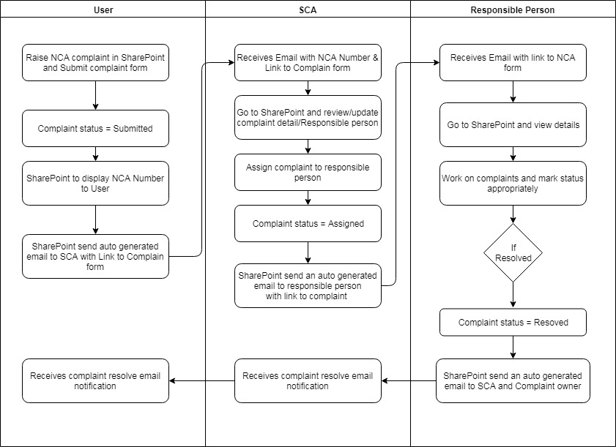

### 4.6.2 SHEQ

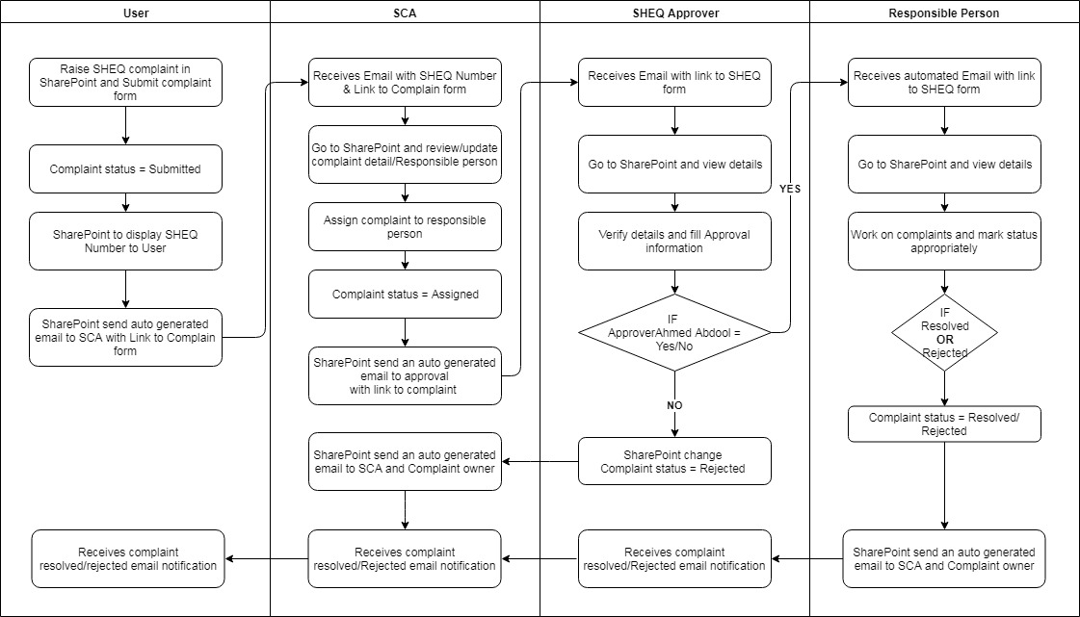

## 4.7 Notification template

<<TBD>>

Need to get template from Unilever team

### 4.7.1. Complaint Submitted notification to SCA

### 4.7.2. Complaint Assigned notification to Responsible Person

### 4.7.3. Complaint Resolved/Rejected notification to SCA and User

## 4.8 Out of scope requirements

* External system access/Integration
* External user access to system
* Decision flow

# User Requirements

* Interactive Office 365, all user accounts when browser accessing Office 365
* Internet Explorer 11
* Application should be accessible from web and mobile on all supported platforms.
* Intuitive user experience
* Quick and easy

---------------- End of Document-----------